CS 499 Module One Assignment Template

Complete this template by replacing the bracketed text with the relevant information.

- Self-Introduction: Address all of the following questions to introduce yourself.

  - How long have you been in the Computer Science program?
I have been enrolled in the Computer Science program for 4 years.

  - What have you learned while in the program? List three of the most important concepts or skills you have learned.
During this time, I have developed essential skills in software development, algorithms, and database management. The three most important concepts I have learned include:
Object-Oriented Programming (OOP) principles, which provide a structured approach to software development.
Data structures and algorithms, which help in optimizing applications for efficiency.
Database management and SQL, essential for handling persistent data storage.

  - Discuss the specific skills you aim to demonstrate through your enhancements to reach each of the course outcomes.
Through this ePortfolio, I aim to demonstrate my ability to design and engineer software, optimize algorithms, and implement robust databases. These enhancements will highlight my coding efficiency, security implementation, and UI/UX design improvements.

  - How do the specific skills you will demonstrate align with your career plans related to your degree?
The skills demonstrated through this project align with my career goals of becoming a proficient software developer specializing in mobile applications and database management.

  - How does this contribute to the specialization you are targeting for your career?
This ePortfolio will showcase my expertise in Android development, secure coding, and database optimization, strengthening my profile in software engineering and mobile app development.

- ePortfolio Set Up:

  - Submit a screen capture of your ePortfolio GitHub Pages home page that clearly shows your URL.
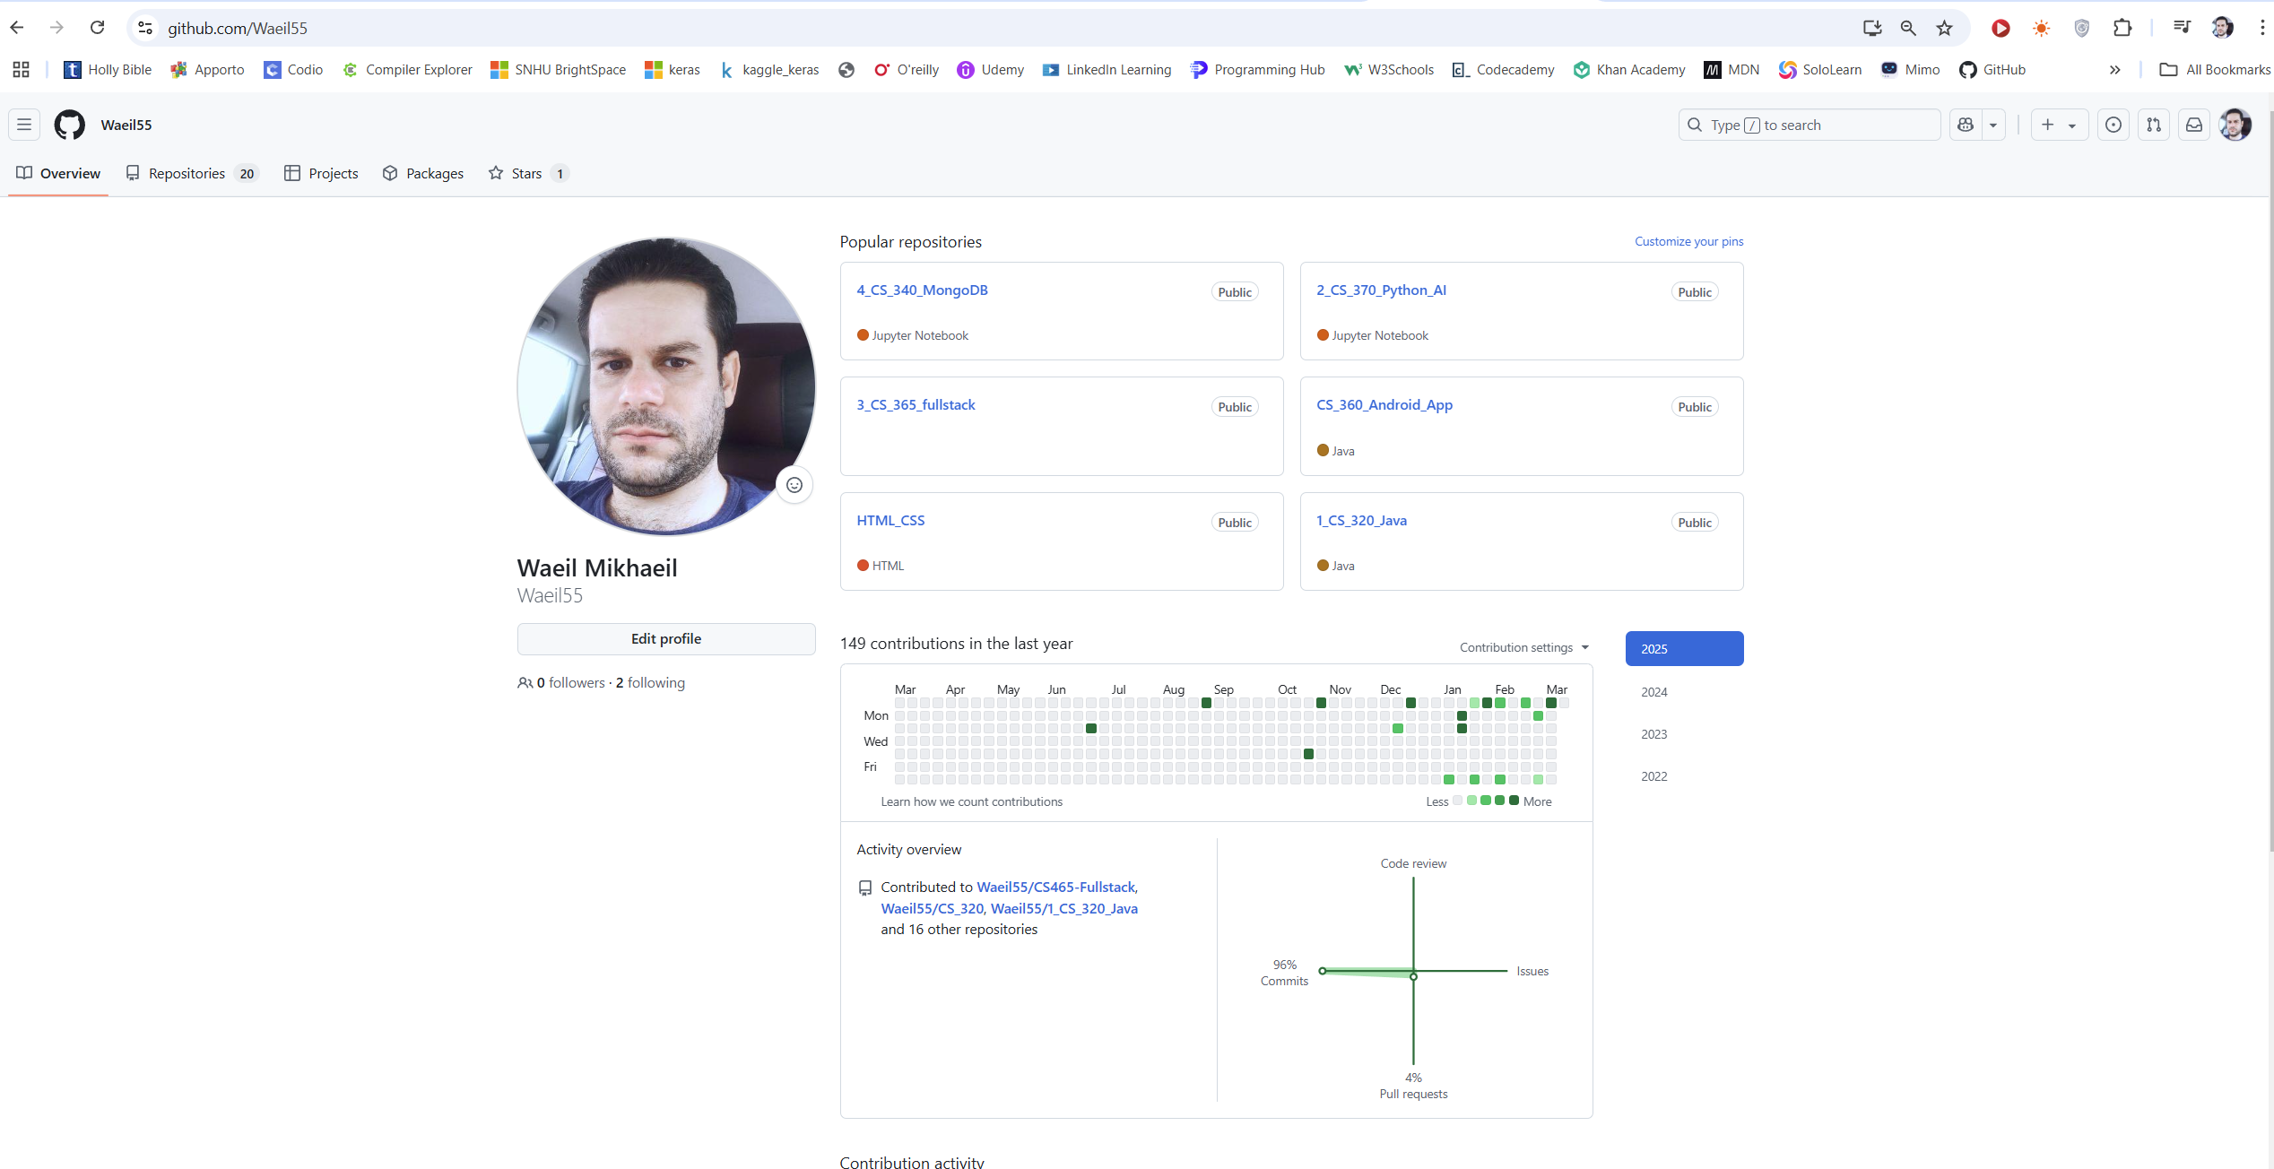
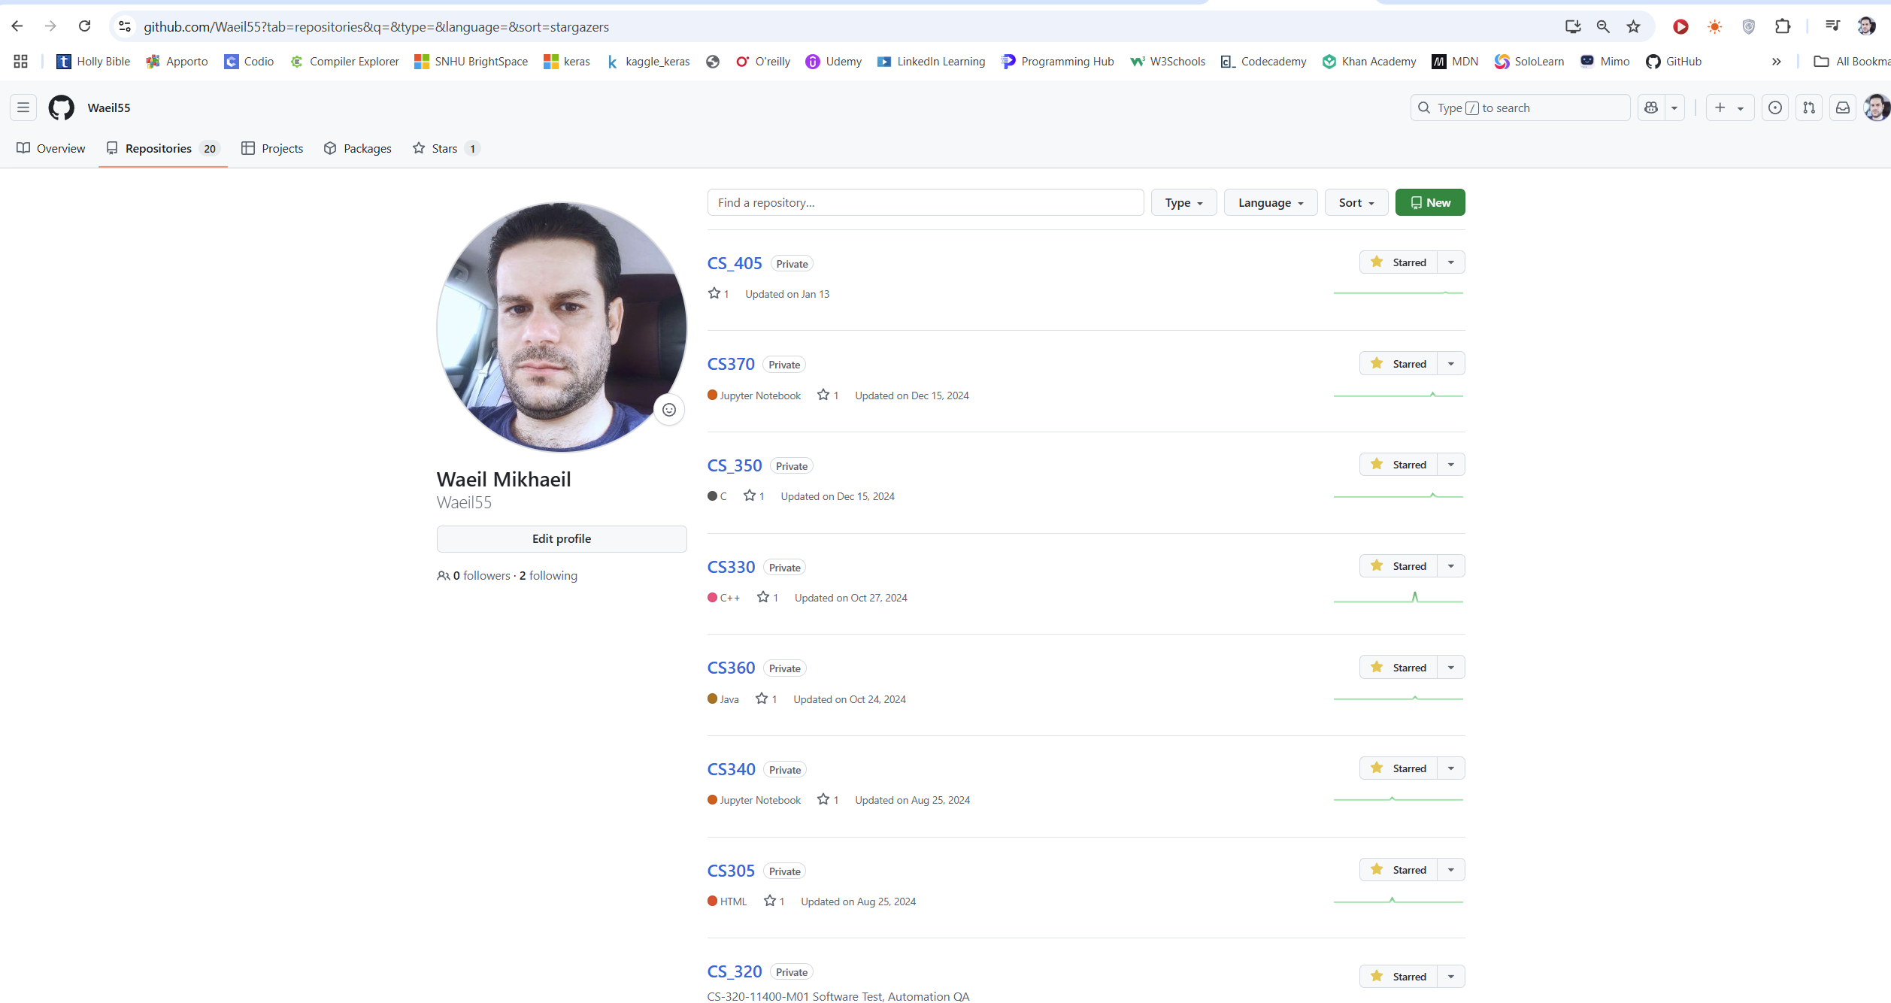
  - Use the GitHub Pages link in the Resource section for directions on:
    - How to create your GitHub website and publish code to GitHub Pages

    - Issues, such as adding links to other sites

  - Paste a screenshot of your GitHub Pages home page with your URL clearly showing in the space below.
https://github.com/Waeil55/CS_499.git

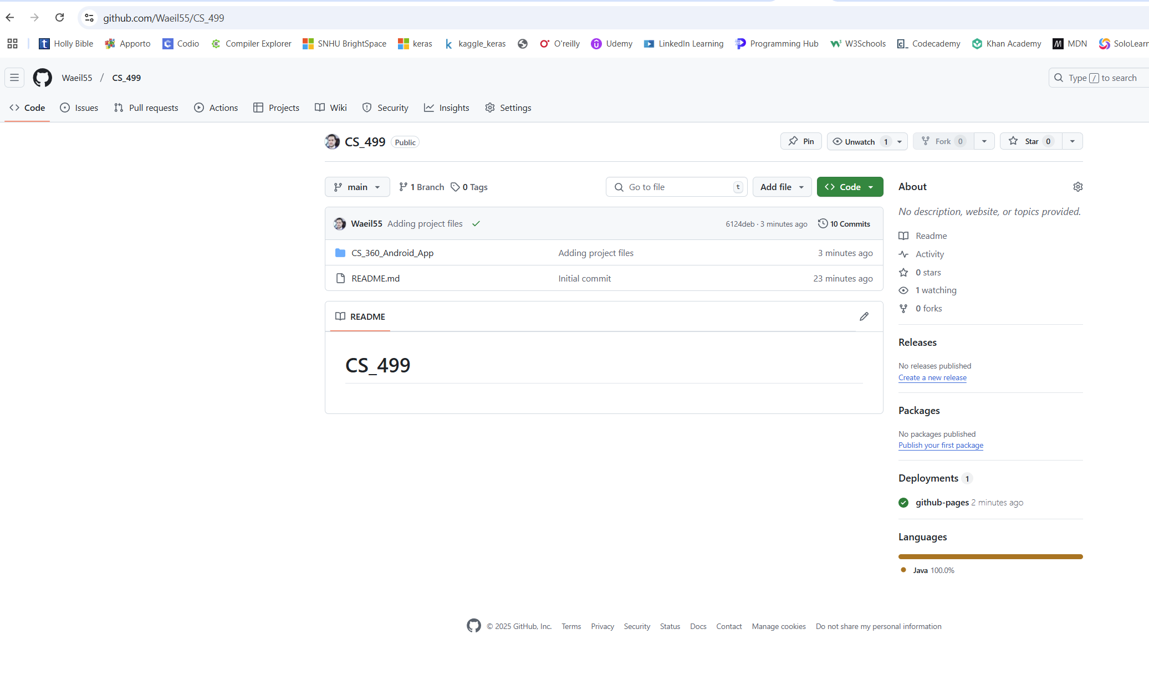
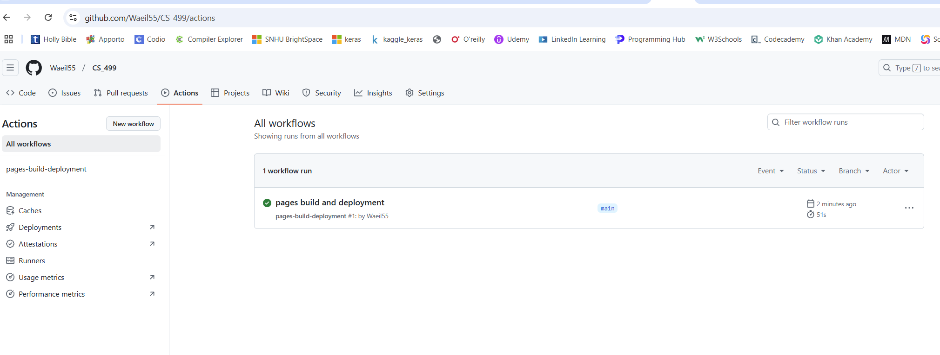
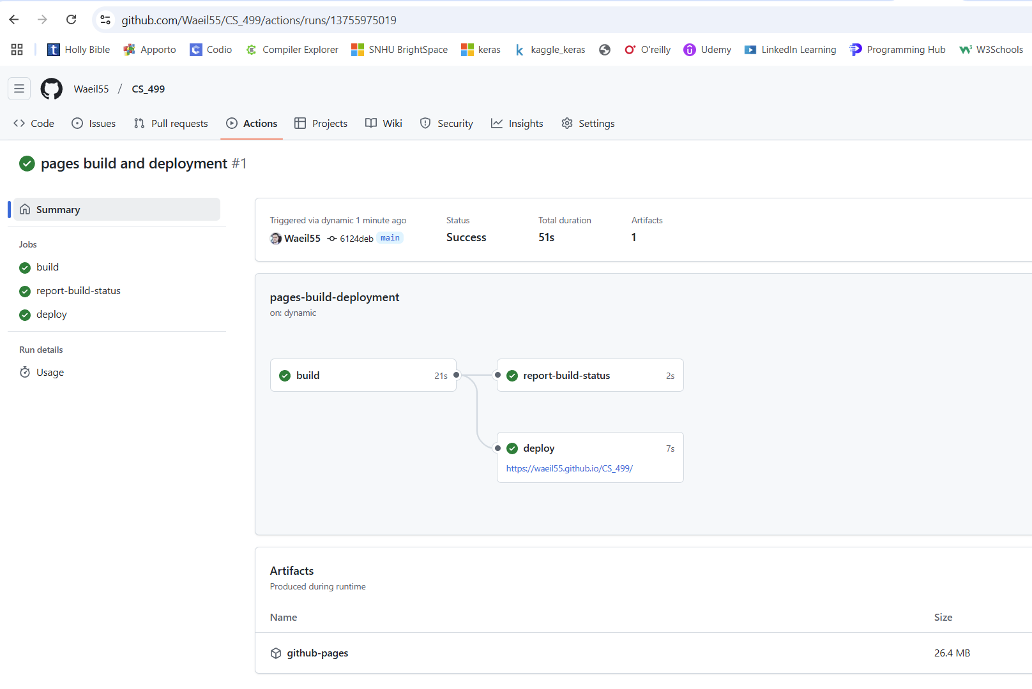

- Enhancement Plan:

  - Category One: Software Engineering and Design
    - Select an artifact that is aligned with the software engineering and design category and explain its origin. Submit a file containing the code for the artifact you choose with your enhancement plan.
Selected Artifact: Event Management Android AppOrigin: Developed in CS360 as a project for mobile application development.

Note: Your artifact may be work from the following courses:

- IT 145: Foundation in Application Development
- CS 250: Software Development Lifecycle
- CS 260: Data Structures and Algorithms
- IT 315: Object Oriented Analysis and Design
- CS 320: Software Testing, Automation, and Quality Assurance
- CS 330: Computational Graphics and Visualization
- CS 340: Advanced Programming Concepts
- CS 350: Emerging Systems Architectures and Technologies
- CS 360: Mobile Architecture and Programming
- IT 365: Operating Environments
- IT 380: Cybersecurity and Information Assurance
- CS 405: Secure Coding
- CS 410: Reverse Software engineering
- IT 340: Network and Telecommunication Management
- IT 380: Cybersecurity and Information Assurance

    - Describe a practical, well-illustrated plan for enhancement in alignment with the category, including a pseudocode or flowchart that illustrates the planned enhancement.
Improve the UI/UX by incorporating modern Material Design components.

Implement unit testing for key functionalities.

Enhance security by implementing user authentication improvements.

1. User launches app
2. Login screen appears
3. User enters credentials
4. Credentials validated against SQLite database
5. If valid, navigate to events list
6. If invalid, show error message

For this category of enhancement, consider improving a piece of software, transferring a project into a different language, reverse engineering a piece of software for a different operating system, or expanding a project’s complexity. These are just recommendations. Consider being creative and proposing an alternative enhancement to your instructor.

Think about what additions to include to complete the enhancement criteria in this category. Since one example option is to port to a new language, that is the kind of scale that is expected. This does not mean you need to port to a new language but instead have an equivalent scale of enhancement. Underlying expectations of any enhancement include fixing errors, debugging, and cleaning up comments, but these are not enhancements themselves.

    - Explain how the planned enhancement will demonstrate specific skills and align with course outcomes.

      - Identify and describe the specific skills you will demonstrate that align with the course outcome.

Demonstrates ability to improve application efficiency.
Showcases the application of search algorithms.
Reinforces knowledge of data validation and integrity.

      - Select one or more of the course outcomes below that your enhancement will align with.
Design and evaluate computing solutions that solve a given problem using algorithmic principles and computer science practices.
Develop a security mindset that anticipates adversarial exploits in software architecture.

Course Outcomes:

- Employ strategies for building collaborative environments that enable diverse audiences to support organizational decision-making in the field of computer science.
- Design, develop, and deliver professional-quality oral, written, and visual communications that are coherent, technically sound, and appropriately adapted to specific audiences and contexts.
- Design and evaluate computing solutions that solve a given problem using algorithmic principles and computer science practices and standards appropriate to its solution while managing the trade-offs involved in design choices.
- Demonstrate an ability to use well-founded and innovative techniques, skills, and tools in computing practices for the purpose of implementing computer solutions that deliver value and accomplish industry-specific goals.
- Develop a security mindset that anticipates adversarial exploits in software architecture and designs to expose potential vulnerabilities, mitigate design flaws, and ensure privacy and enhanced security of data and resources.

  - Category Two: Algorithms and Data Structures

- Select an artifact that is aligned with the algorithms and data structures category and explain its origin. Submit a file containing the code for the artifact you choose with your enhancement plan. You may choose work from the courses listed under Category One.
Selected Artifact: Event Management Android AppOrigin: Developed in CS360 with SQLite as the database backend.

- Describe a practical, well-illustrated plan for enhancement in alignment with the category, including a pseudocode or flowchart that illustrates the planned enhancement.

Optimize event search functionality using a binary search algorithm for faster retrieval.
Implement caching mechanisms to improve app performance.
Introduce data validation algorithms for better data integrity.

For this category of enhancement, consider improving the efficiency of a project or expanding the complexity of the use of data structures and algorithms for your artifact. These are just recommendations. Consider being creative and proposing an alternative enhancement to your instructor. Note: You only need to choose one type of enhancement per category.

Think about what additions to include to complete the enhancement criteria in this category. Since one example option is to port to a new language, that is the kind of scale that is expected. Perhaps you might increase the efficiency and time complexity of an algorithm in an application and detail the logic of the increased time complexity. Remember, you do not need to port to a new language but instead have an equivalent scale of enhancement. Underlying expectations of any enhancement include fixing errors, debugging, and cleaning up comments, but these are not enhancements themselves.

- Explain how the planned enhancement will demonstrate specific skills and align with course outcomes.

  - Identify and describe the specific skills you will demonstrate to align with the course outcome.

Demonstrates ability to improve application efficiency.
Showcases the application of search algorithms.
Reinforces knowledge of data validation and integrity.

  - Select one or more of the course outcomes listed under Category One that your enhancement will align with.

Design and evaluate computing solutions that solve a given problem using algorithmic principles.

Demonstrate an ability to use well-founded and innovative techniques, skills, and tools in computing practices.

  - Category Three: Databases

    - Select an artifact that is aligned with the databases category and explain its origin. Submit a file containing the code for the artifact you choose with your enhancement plan. You may choose work from the courses listed under Category One.

Selected Artifact: Event Management Android AppOrigin: Developed in CS360 using SQLite3 as the database.

    - Describe a practical, well-illustrated plan for enhancement in alignment with the category, including a pseudocode or flowchart that illustrates the planned enhancement.

Normalize the database to improve efficiency and prevent data redundancy.
Implement stored procedures for complex queries.
Add data encryption for user privacy.

For this category of enhancement, consider adding more advanced concepts of MySQL, incorporating data mining, creating a MongoDB interface with HTML/JavaScript, or building a full stack with a different programming language for your artifact. These are just recommendations; consider being creative and proposing an alternative enhancement to your instructor. Note: You only need to choose one type of enhancement per category.

Think about what additions to include to complete the enhancement criteria in this category. Since one example option is to port to a new language, that is the kind of scale that is expected. Perhaps you might increase the efficiency and time complexity of an algorithm in an application and detail the logic of the increased time complexity. Remember, you do not need to port to a new language but instead have an equivalent scale of enhancement. Underlying expectations of any enhancement include fixing errors, debugging, and cleaning up comments, but these are not enhancements themselves.
    - Explain how the planned enhancement will demonstrate specific skills and align with course outcomes.

      - Identify and describe the specific skills you will demonstrate that align with the course outcome.

Demonstrates database normalization techniques.
Shows proficiency in database security.
Implements complex SQL queries for data management.

      - Select one or more of the course outcomes listed under Category One that your enhancement will align with.

Develop a security mindset that anticipates adversarial exploits in software architecture.

Demonstrate an ability to use well-founded and innovative techniques, skills, and tools in computing practices.

- ePortfolio Overall Skill Set

  - Accurately describe the skill set to be illustrated by the ePortfolio overall.
    - Skills and outcomes planned to be illustrated in the code review
Writing efficient and maintainable code.
Implementing design patterns and best practices.

    - Skills and outcomes planned to be illustrated in the narratives
Explaining technical enhancements and decisions.
Demonstrating critical thinking in software improvement.

    - Skills and outcomes planned to be illustrated in the professional self-assessment
Evaluating personal growth in computer science.
Identifying areas for continued learning and development.

https://github.com/Waeil55/CS_499.git

Databases - Data Encryption

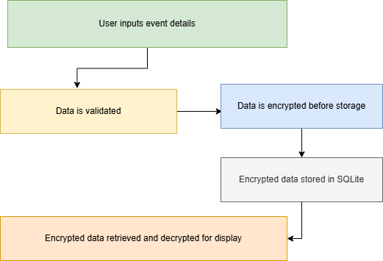

Software Engineering - Login Process
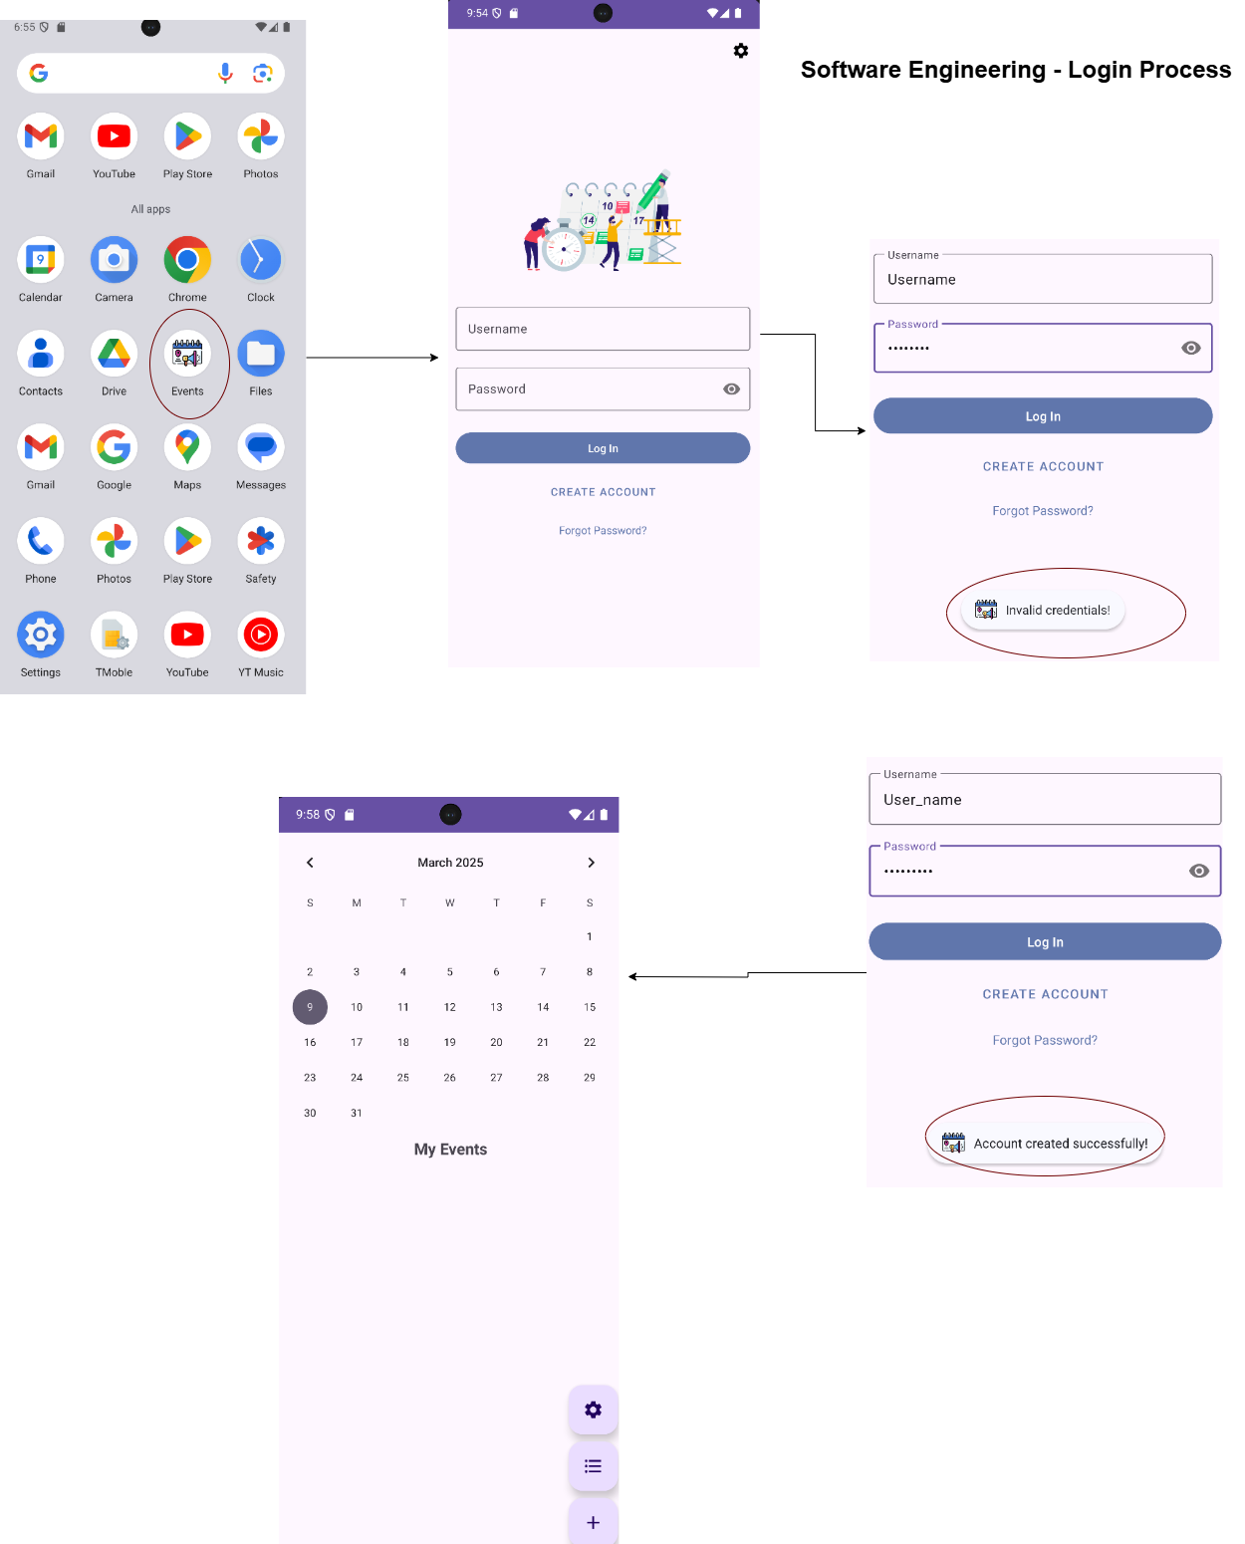
Algorithms - Caching Mechanism
